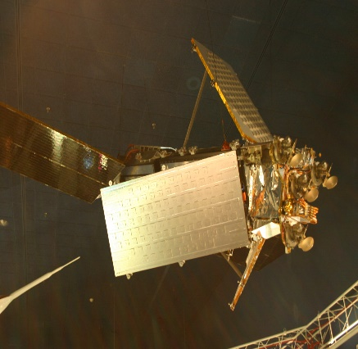
crajaram@8202aa

MKCL’s Knowledge Lit
Skill Development program


KLiC
slllllkkhghgh
AutoCAD

